 | DARRELL L. WILLIS
10/23/2008
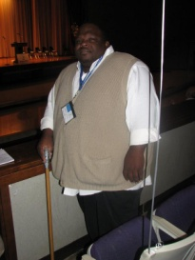 | 100 South New St Apt 406  (540)836-6280  Darrell.Willis.246@gmail.com  http://The.BearCave.tripod.com/

Objectives
To utilize my skills, training, experience, and education, to become a valued member of a team.
Education
Blue Ridge Community College
2008 – Present
Enrolled in the Mechanical Design Engineering
Woodrow Wilson Center for Employment
2006 - 2008
Architectural Drafting Program Mechanical
Vance-Granville Community College
1988 – 1990
Heating & Air Conditioning
Earl C. Clements Job Corps Academy
1986
Construction Plumbing Certified
experience
Student Internship | James Madison University
4/08 - 5/08

Recreation Equipment Room Aide/ Manager | Woodrow Wilson Rehabilitation Center
9/06 - 2/08

Evening Supervisor | OMRDD Group Home
9/96 - 10/01

Group Home Supervisor | Schenectady Association for Retarded Citizens
1994 - 1996
skills & Qualifications
- Read Mechanical/Architecture drawings, Blueprints, and Schematics
- Develop detailed working drawings in AutoCAD 2007
  - Orthographic projection, Isometric drawings, CAM/CAD
  - Developments & Intersections, Assembly drawings, Dimensioning
  - Auxiliary views, Symbols, Sectional drawing, Cam and Gears
- Computer (non-CAD)
  - Applications (basic use)
    - Microsoft Word, Excel, Publisher, Outlook, Internet Explorer, Email
- General Skills
  - Mathematics courses during drafting training and at community college, Event planning, Team building
  - Budget planning, Scheduling and organization of work, Works well under pressure

